1. **SCOPE** 
   1. This procedure covers permitted/correct usage of certificates, logos and by both IAS and IWCC
   2. Clients registered with IWCC are issued with a certificate signed by the GM (or his nominee). This allows the company to display the IWCC Certification Mark.
   3. If the client’s scope of the registration lies within either of IWCC’s schedules of accreditation, the IWCC certificate will normally contain the appropriate Accreditation Mark. In these cases, the IWCC Registration Mark, incorporating the appropriate accreditation Mark may be used.
   4. The format and uses, of these marks are strictly controlled. (See IWCC Leaflet ‘Guidelines - use of Registration Marks’).
2. **RESPONSIBILITIES**

Responsibilities are as defined in the text of this IWCC Procedure.

1. **FORMAT AND DEFINITION** 
   1. Examples of the Marks covered by IWCC’s Accreditations are included in the IWCC Leaflet ‘Guidelines for use of certification and registration marks.’ And the separate guidance which has been produced with regard to the Product Certification Mark.
   2. A IWCC that provides a certification mark or logo shall document the conditions for use and shall appropriately manage the rights for usage and representation.
   3. ISO/IEC 17030 provides requirements for use of third-party marks.
   4. The IWCC shall require that a certified person signs an agreement for the following reasons:
   5. to comply with the relevant provisions of the certification scheme;
   6. to make claims regarding certification only with respect to the scope for which certification has been granted;
   7. not to use the certification in such a manner as to bring the IWCC into disrepute, and not to make any statement regarding the certification which the IWCC considers misleading or unauthorized;
   8. to discontinue the use of all claims to certification that contain any reference to the IWCC or certification upon suspension or withdrawal of certification, and to return any certificates issued by the IWCC;
   9. not to use the certificate in a misleading manner.
   10. A IWCC shall address, by means of corrective measures, any misuse of its certification mark or logo.
2. **USE OF THE MARKS BY IWCC CLIENTS** 
   1. Compliance with the correct usage of the IWCC Registration and Certification Marks is required in the IWCC Regulations Relating to Registration. The attention of a client is drawn to these conditions when the Certificate of Registration is issued.
   2. The correct uses of the IWCC Registration Marks (for IAS clients)
   3. The permitted uses of the IWCC Registration and Certification Marks are summarised for clients in the IWCC leaflet ‘Guidelines - use of Registration Marks’.
3. **USE OF THE MARKS BY IWCC** 
   1. IAS Accreditation Marks
      1. The Accreditation Marks may be used on their own or in conjunction with the IWCC Certification Mark on IWCC certificates, literature and in advertisements.
4. **MISUSE OF THE IWCC MARKS** 
   1. Misuse by a client
      1. Misuse of Marks may be identified when Assessors examine a registered company’s use of Marks, during certification audits. These shall be forwarded to the appropriate Client Manager via the assessment report. The Assessor will clarify the requirements on usage to the client at the time.
      2. Misuses of mark may be identified by IWCC office staff from client stationery, or reported by a client or other external party.
      3. In all instances the client will be requested, in writing, that the client shall cease the misuse as soon as is reasonably possible.
      4. The VM shall be notified of all instances where Marks have been misused, providing copies of all related documentation for retention in the Misuse of

Marks File.

* + 1. Correspondence may be received by the VM at office, regarding possible misuse of Marks. In these circumstances the matter is acknowledged by the VM who instigates any necessary investigation or corrective actions. The VM records the details on the Misuse of Marks database completing and allocating a sequential number to each record.
    2. Outstanding misuses of the mark will be monitored by the Quality Systems Department. Misuse of the Mark, if not closed out as agreed with IWCC, shall lead to cancellation of registration (Section IWCC-P-12).
  1. Misuse by non-clients
     1. Notification of the use or misuse of any IWCC Mark by a non-client organisation will be directed to the VM at HO.
     2. The VM will record the details and attempt to resolve the matter directly with the company concerned.
     3. At the discretion of the MD, in instances where non-clients are reported for displaying the IWCC logo, a standard letter has been prepared for issue by the IWCC solicitors.

1. **RECORDS**

7.1 A record of the details of all notifications of misuse will be kept in the Misuse of Marks file held by the VM and also on the database.

7.2 Evidence of closure shall be recorded on the database by the HO-IWCC.

1. **REFERENCES**

ISO/IEC 17030 requirements for use of third-party marks

1. **Samples of use IWCC logo IAS Combined Marks**

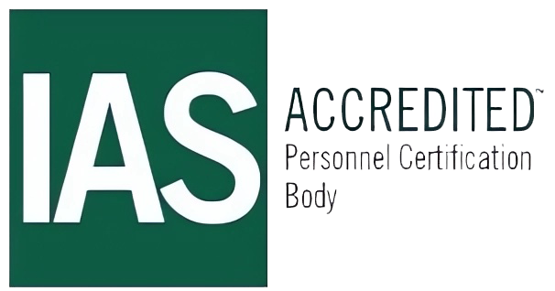

**PCB-163**



** **

